

Faculty of Engineering

Electronics and Communications Department

Helwan University – Egypt

Smart Traffic Control

Supervised by:

Prof. Gamal Abdelfadeel

**Team**

**Smart Traffic Control**

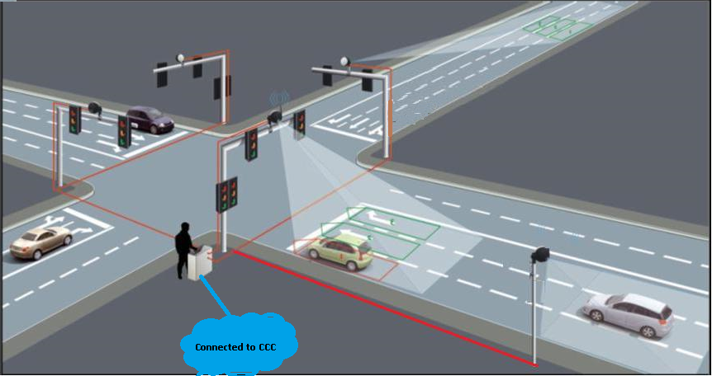

1. **Ahmed Reda**
2. **Ahmed Omar**
3. **Ahmed Soliman**
4. **Ahmed Shaaban**
5. **Salwa**

Abstract

A Smart Traffic Control System (STCS) represents an advanced technological approach aimed at enhancing the efficiency and safety of urban transportation networks. Utilizing real-time data acquisition and analysis, the system integrates various technologies such as Internet of Things (IoT) sensors, artificial intelligence (AI), and machine learning (ML) algorithms to dynamically manage and optimize traffic flow. The primary objective of STCS is to reduce congestion, minimize travel time, and decrease the environmental impact of vehicles. By adapting to changing traffic conditions, predicting congestion patterns, and providing timely information to drivers and traffic management authorities, the system improves overall traffic management. Additionally, STCS enhances emergency response times by prioritizing routes for emergency vehicles and supports sustainable urban development by encouraging the use of public transportation and non-motorized modes of travel. The implementation of such systems promises a significant transformation in urban mobility, contributing to smarter, more connected, and more sustainable cities.

A Smart Traffic Control System (STCS) is a cutting-edge approach designed to revolutionize urban transportation management by leveraging advanced technologies. The system aims to address the challenges of traffic congestion, road safety, and environmental sustainability through the integration of Internet of Things (IoT) sensors, artificial intelligence (AI), machine learning (ML) algorithms, and advanced communication networks.

At the core of STCS is the ability to collect and analyze real-time data from various sources, including traffic cameras, embedded road sensors, GPS data from vehicles, and weather information. This data is processed to understand current traffic conditions, predict future traffic patterns, and respond dynamically to changing circumstances. For instance, AI algorithms can analyze traffic flow and adjust traffic signal timings in real-time to optimize traffic movement, reduce waiting times at intersections, and prevent bottlenecks.

Machine learning models play a crucial role in STCS by continuously learning from traffic data to improve predictions and decision-making processes. These models can identify patterns and trends, such as peak traffic hours, accident-prone zones, and the impact of special events on traffic flow. By anticipating congestion and suggesting alternative routes, STCS helps in distributing traffic more evenly across the network.

Moreover, STCS enhances the efficiency of public transportation systems by providing real-time updates and optimizing bus and train schedules based on current traffic conditions. It supports non-motorized modes of travel, such as cycling and walking, by ensuring safer and more accessible routes. The system also integrates with smart parking solutions to guide drivers to available parking spaces, reducing the time spent searching for parking and subsequently easing urban congestion.

A significant advantage of STCS is its contribution to environmental sustainability. By reducing idle times and stop-and-go driving, the system lowers fuel consumption and decreases the emission of greenhouse gases and pollutants. Furthermore, it promotes the use of eco-friendly transportation options and supports initiatives like carpooling and ride-sharing.

Emergency response is another critical area where STCS proves beneficial. By prioritizing traffic signals and providing clear routes, the system ensures that emergency vehicles can reach their destinations swiftly and safely. This capability not only improves response times but also enhances the overall effectiveness of emergency services.

Implementing STCS requires a collaborative effort between city planners, transportation authorities, technology providers, and the community. It involves significant investments in infrastructure, such as installing sensors and upgrading communication networks. However, the long-term benefits, including reduced congestion, improved air quality, and enhanced quality of life, justify these investments.

Table of Contents

1. Introduction 7

1.1 Background……….. 7

1.2 Purpose of the Study………….. 7

1.3 Scope……… 7

1.4 Methodology……….. 7

2. Literature Review 7

2.1 Traditional Traffic Control Systems………….. 7

2.2 Evolution of Smart Traffic Control Systems…………… 7

2.3 Technologies Involved………………….. 7

2.4 Case Studies……………. 7

3. System Architecture 7

3.1 Overview of System Components…….. 7

3.2 Hardware Components………… 7

3.2.1 Sensors………. 7

3.2.2 Traffic Lights………… 7

3.3 Software Components………… 7

3.3.1 Traffic Management Software……….. 7

3.3.2 Data Analytics Tools………. 7

3.4 Communication Infrastructure……….. 7

3.4.1 Network Requirements……….. 7

3.4.2 Communication Protocols……….. 7

4. Design and Implementation……… 7

4.1 System Design……… 7

4.1.1 Functional Requirements………….. 7

4.1.2 Non-Functional Requirements…………. 8

4.2 Implementation Plan……….. 8

4.2.1 Timeline………. 8

4.2.2 Resource Allocation………. 8

4.3 Integration with Existing Systems……. 8

4.4 Pilot Testing………… 8

5. Technological Components 8

5.1 Artificial Intelligence (AI) and Machine Learning (ML)…………. 8

5.2 Big Data Analytics…………… 8

5.3 Cloud Computing……………… 8

5.4 Edge Computing…… 8

6. Traffic Data Collection……….. 8

6.1 Types of Data Collected………… 8

6.1.1 Vehicle Count………. 8

6.1.2 Speed Monitoring………. 8

6.1.3 Incident Detection…… 8

6.2 Data Collection Methods……. 8

6.2.1 Sensor Networks……… 8

6.2.2 Video Surveillance……… 8

6.2.3 Crowdsourcing…….. 8

6.3 Data Storage and Management……….. 8

7. Traffic Data Analysis……………. 8

7.1 Real-time Data Processing……………. 8

7.2 Predictive Analytics…………… 8

7.3 Traffic Pattern Recognition……….. 9

7.4 Incident Detection and Management…………. 9

7.5 Visualization Tools……. 9

8. Traffic Control Strategies………… 9

8.1 Adaptive Traffic Signal Control…………. 9

8.2 Dynamic Traffic Routing……….. 9

8.3 Congestion Management……… 9

8.4 Emergency Vehicle Prioritization………. 9

8.5 Pedestrian Safety Measures……….. 9

9. User Interface and Experience…….. 9

9.1 Control Room Interface………. 9

9.2 Mobile Applications…… 9

9.3 Public Information Systems……….. 9

9.4 User Feedback Mechanisms……… 9

10. Security and Privacy…… 9

10.1 Data Security Measures……….. 9

10.2 Privacy Concerns and Solutions…. 9

10.3 Cybersecurity Threats and Mitigation……… 9

10.4 Compliance with Regulations……… 9

11. Performance Evaluation…….. 9

11.1 Key Performance Indicators (KPIs)……. 9

11.2 Evaluation Metrics 9

11.3 Case Study: Implementation in a Pilot Area……… 9

11.4 Results and Analysis…… 10

12. Challenges and Solutions……… 10

12.1 Technical Challenges……………….. 10

12.2 Financial Constraints……………… 10

12.3 Public Acceptance………. 10

12.4 Legal and Regulatory Issues………. 10

13. Future Directions………. 10

13.1 Upcoming Technologies………… 10

13.2 Potential Improvements…………. 10

13.3 Scalability Considerations………….. 10

13.4 Long-term Vision……… 10

14. Conclusion……….. 10

14.1 Summary of Findings………… 10

14.2 Final Thoughts………. 10

14.3 Recommendations for Stakeholders……….. 10

15. References……… 10

15.1 Books……… 10

15.2 Journals……. 10

15.3 Reports…… 10

16. Appendices……….. 10

16.1 Glossary of Terms…………. 10

16.2 Technical Specifications………. 10

16.3 Additional Data Tables…… 11

16.4 Survey Questionnaires………. 11

16.5 Interview Transcripts……….. 11

# 1. Introduction

# 2. Literature Review

# 3. System Architecture

# 4. Design and Implementation

# 5. Technological Components

# 6. Traffic Data Collection

# 7. Traffic Data Analysis

# 8. Traffic Control Strategies

# 9. User Interface and Experience

# 10. Security and Privacy

# 11. Performance Evaluation

# 12. Challenges and Solutions

# 13. Future Directions

# 14. Conclusion

# 15. References

# 16. Appendices